Chapter 3, Problem 63.

Find v_{x}, and i_{x} in the circuit shown in Fig. 3.107.

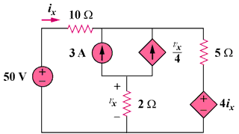

Figure 3.107
For Prob. 3.63.

